# Create a Todo App in SAP Build Part 2 – List Todos

Now that you have created the Todo Backend app, you can create the Todo Web App.

When working with SAP Build Apps, it’s a good idea to save after each step.

In SAP Build Apps, click Create.

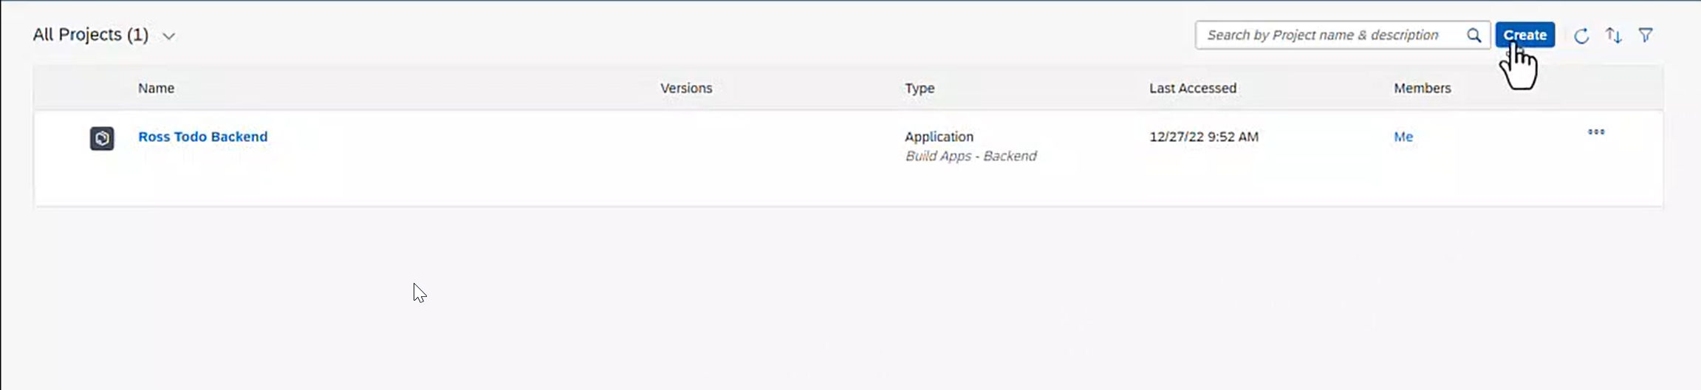

Click Build an Application.

Click Web & Mobile Application.

Enter the Project name and click Create.

The app is created, and the UI CANVAS is opened to the main page.

On the left is the toolbox which contains controls you can drag onto the canvas to create the interface. In addition to the CORE controls, you can use the Marketplace to install more controls.

On the bottom right is the TREE, which shows the interface in outline form. It’s often easier to arrange controls using the TREE.

The center of the screen is the canvas that shows what the interface will look like. On the top right is the properties pane which you use to configure controls.

Change the Page name to something like My Todos. If you selected a control and the Page properties aren’t visible, click on the whitespace on the canvas.

Select the Title control and change the Content to something like My Todos.

Delete the Text control. Save the app.

To enable our app to access the Todo backend app, we have to configure authorization. Click the Auth icon on the top menu.

Click ENABLE AUTHORIZATION.

And click SAP BTP authentication.

Click OK.

Next, we have to create a Data Resource that connects to the Todo backend. Click Data in the top menu.

Click ADD INTEGRATION.

Click CLOUD FUNCTIONS.

Since you created the Todo backend app in the same subaccount, it will show up here. Click it.

The Todo entity is shown on the left and the functions are shown to the right.

Click INSTALL INTEGRATION.

Click ENABLE DATA ENTITY.

The Todo entity is enabled.

Select the Cloud functions tab, then select the GetTodos function.

Click ENABLE CLOUD FUNCITON.

Return to the UI CANVAS.

Although we can construct a list using the CORE controls, we can install a preconstructed list from the MARKETPLACE. Click MARKETPLACE.

If you don’t see the Basic list, you can use the search field at the top of the screen to find it.

Click the Basic List, then click INSTALL.

You’ll find the Basic list control at the top of the list of controls on INSTALLED tab.

Drag onto the canvas below the Title control.

With the list selected, click Configure in the PROPERTIES.

Click the Todo entity tile.

Drag the Available fields onto the controls.

Then click SAVE AND EXIT.

To run the app, click LAUNCH in the top menu.

Click OPEN PREVIEW PORTAL.

Click Open web preview.

Click OPEN.

